B.E.T POLYTECHNIC

[Recognized by the Govt of Karnataka approved by AICTE, New Delhi]

Bharthinagara (KMDOddi), Manday-571422

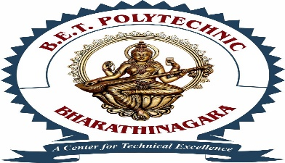

ACTIVITY

ON

Multimedia questions, train ticket booking and moving car

Submitted in partial full meant of the requirement for the award of

DIPLOMA IN COMPUTER SCINCE

Submitted BY

Nithin Gowda A P

SUBJECT: Multimedia and animation

COURSECODE: 20CS21P

Reg no: 410CS23035

*Under the guidance of*

Miss. Ramya M P BE.M.tech

Lecturer

Computer Science & Engg

B.E.T POLYTECHNICE

Bharthinagara, Mandya-571422

2023-2024